**Commands of the day:**

**Pwd** : (present working directory)

Displays the name of the current working directory.

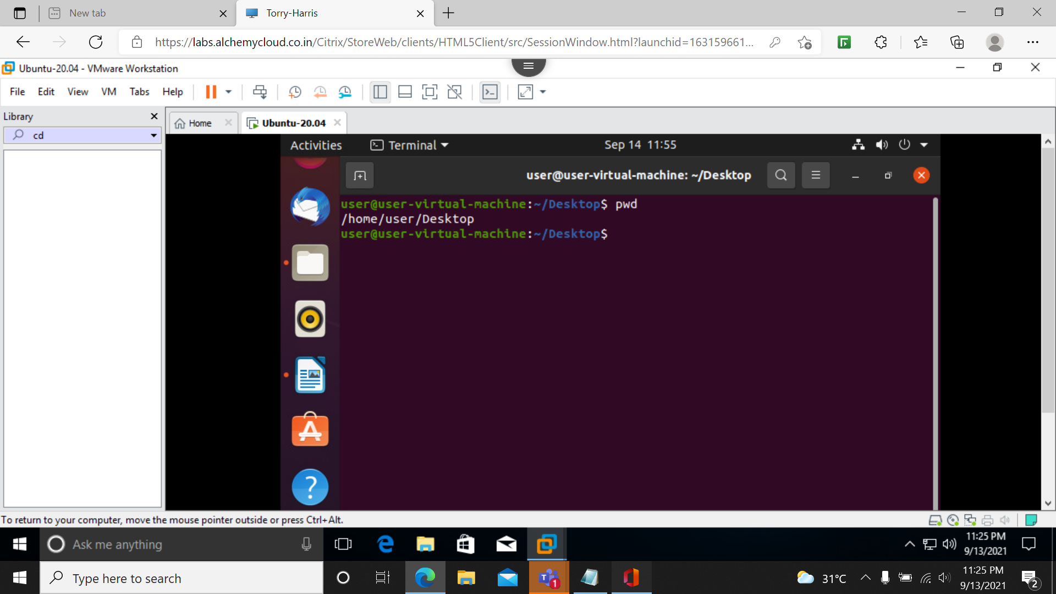

**Ls**: list the files and folders in the present directory.

**Ls –a:** list all

**Ls –A:** list almost all expect hidden folders

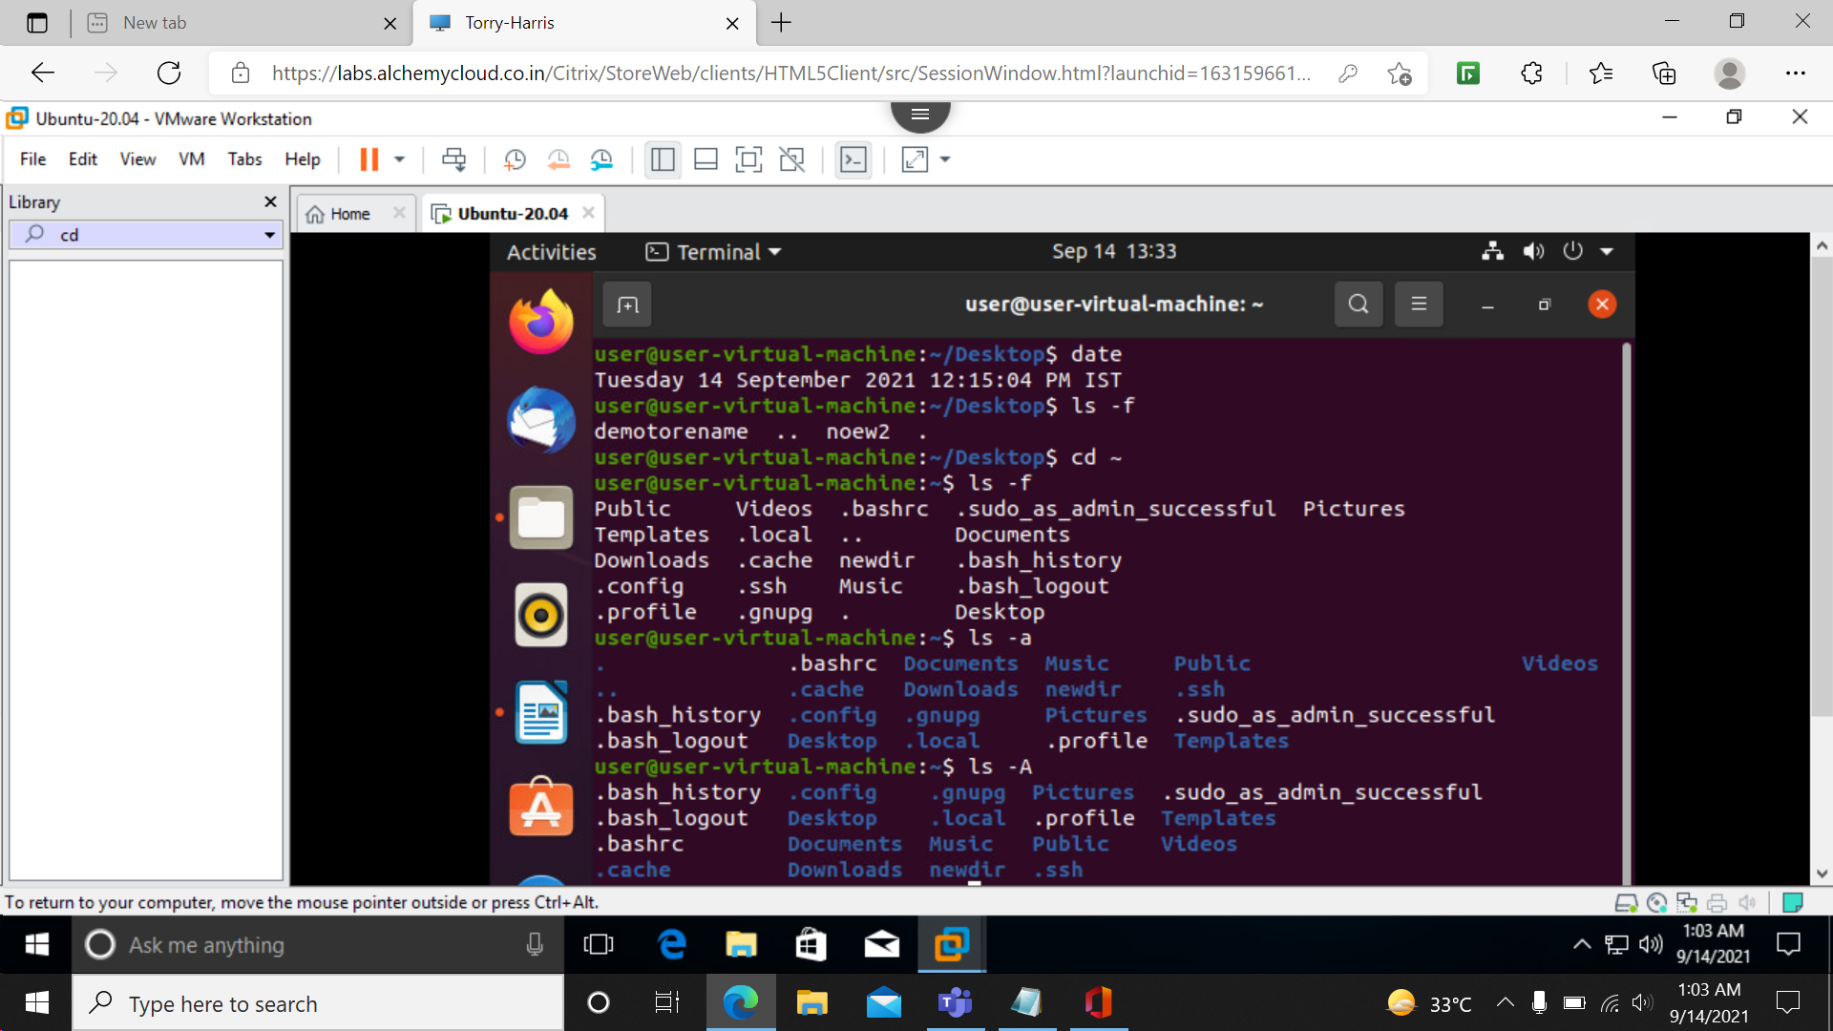

**Cd: Change Directory**

**Cd /:** root directory will be present working directory

**Cd /home/user/Desktop/demo1**: chang to diterctory in given path

**Cd ~**:to user directory

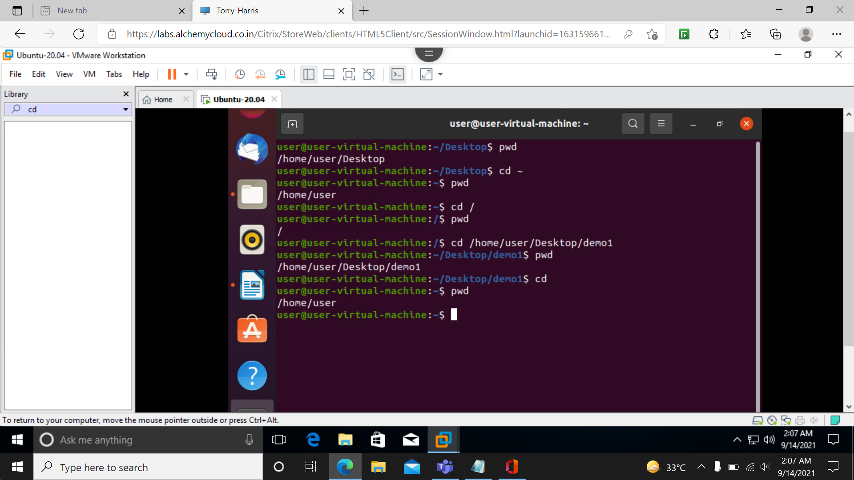

**Mkdir** :**make directory**

Used to create new directory.

**Mkdir demo{1,2,3,4,5}:**

**Mkdir -p 1/2/3/4:**

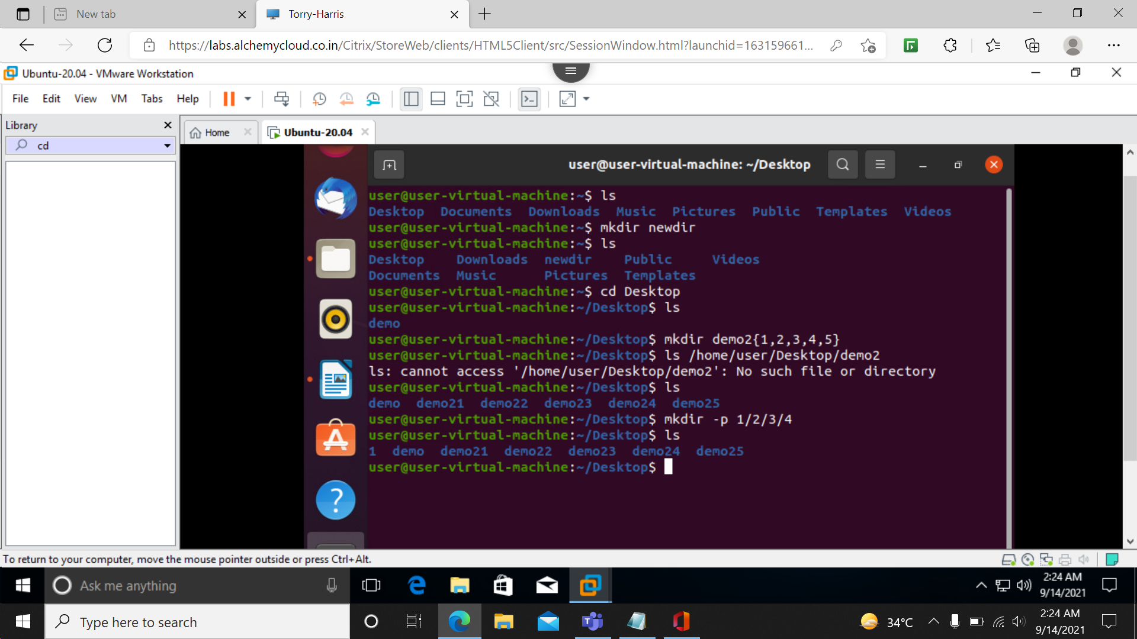

**Rmdir :** to remove directories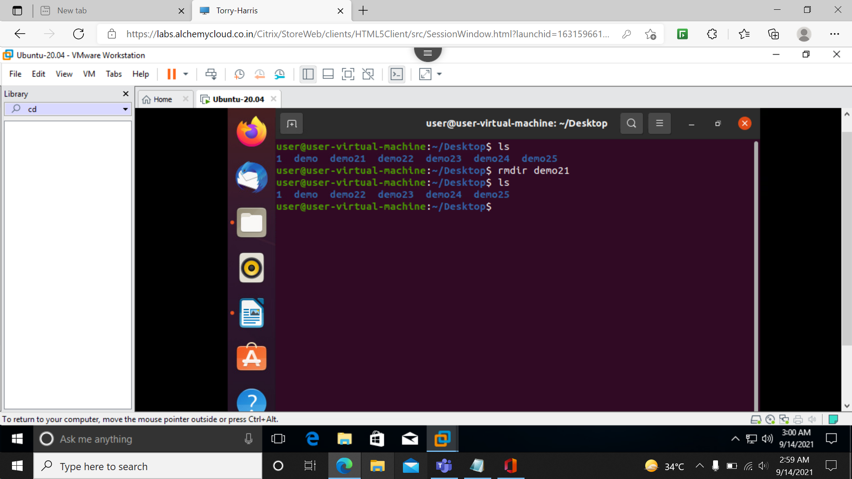

**Mv source destination:**

Used to rename file or to move file from one directory to another.

**Mv demo3 demore** : To rename demo3 to demore.

**Mv demore /home/user/Desktop/demo1**: to move demore from desktop to demo1.

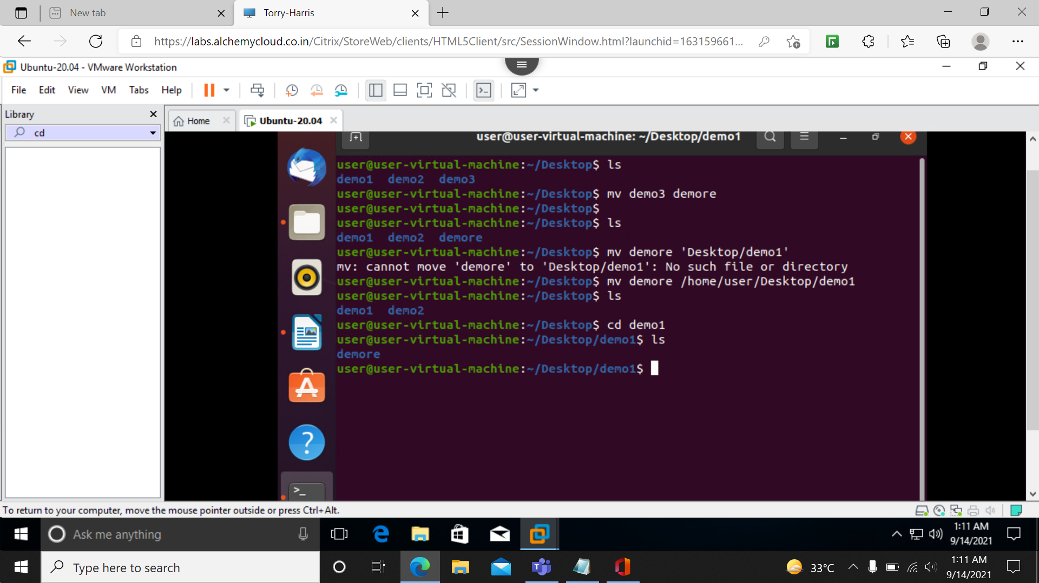

**Cp source destination: :** to copy from one file to another

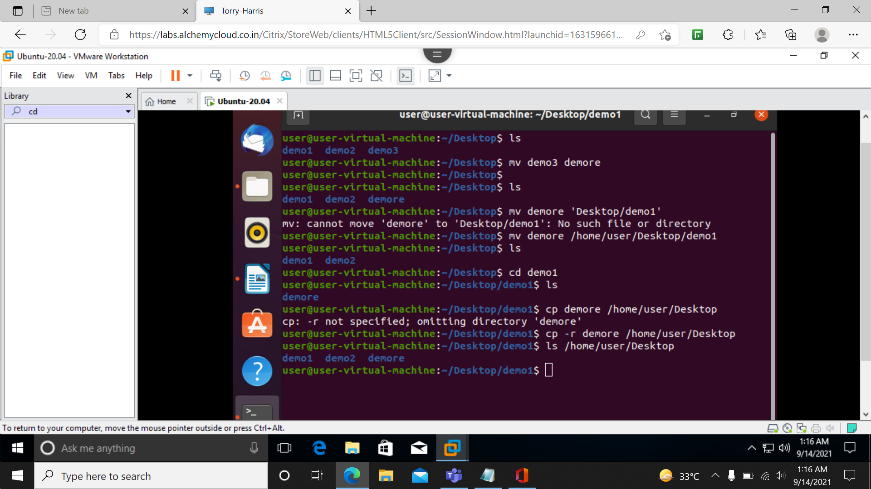

**Echo :**

Used to print out message on to the terminal.

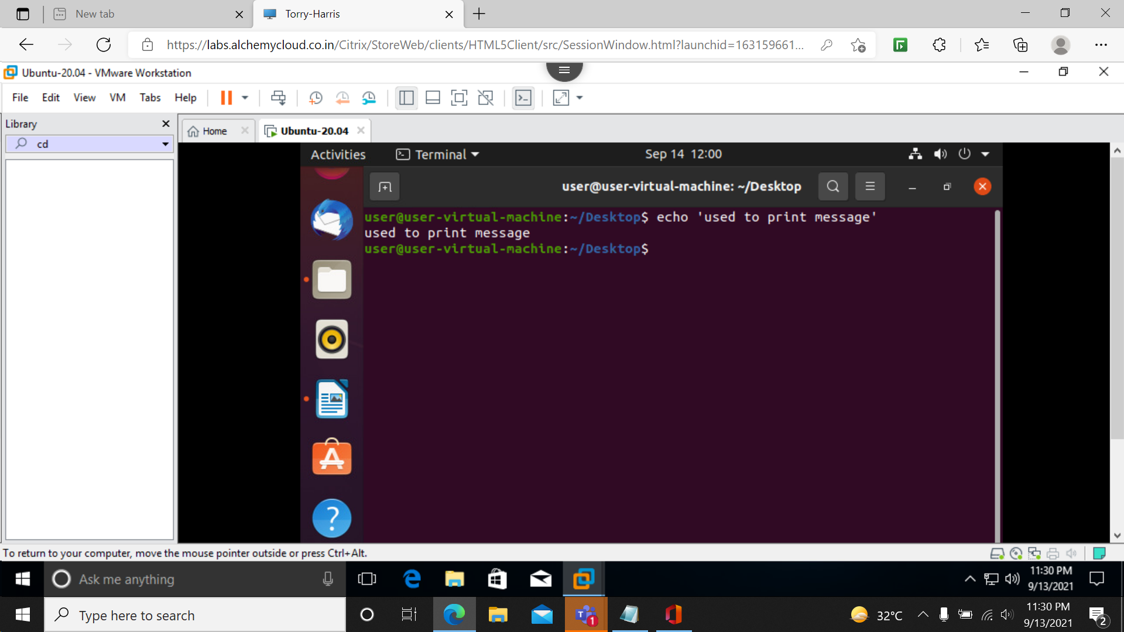

**Clear :**

Clear the terminal.

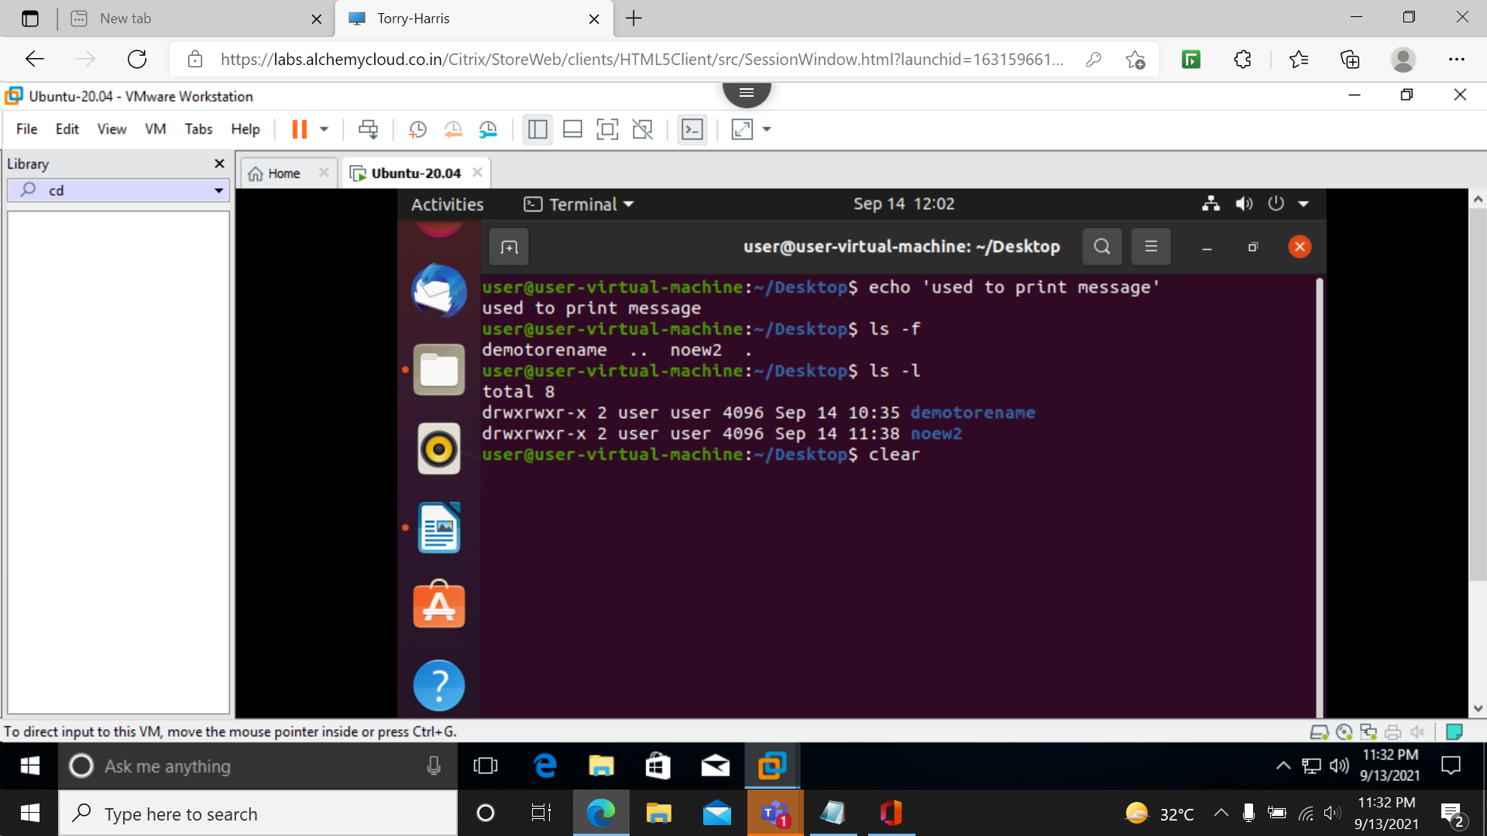

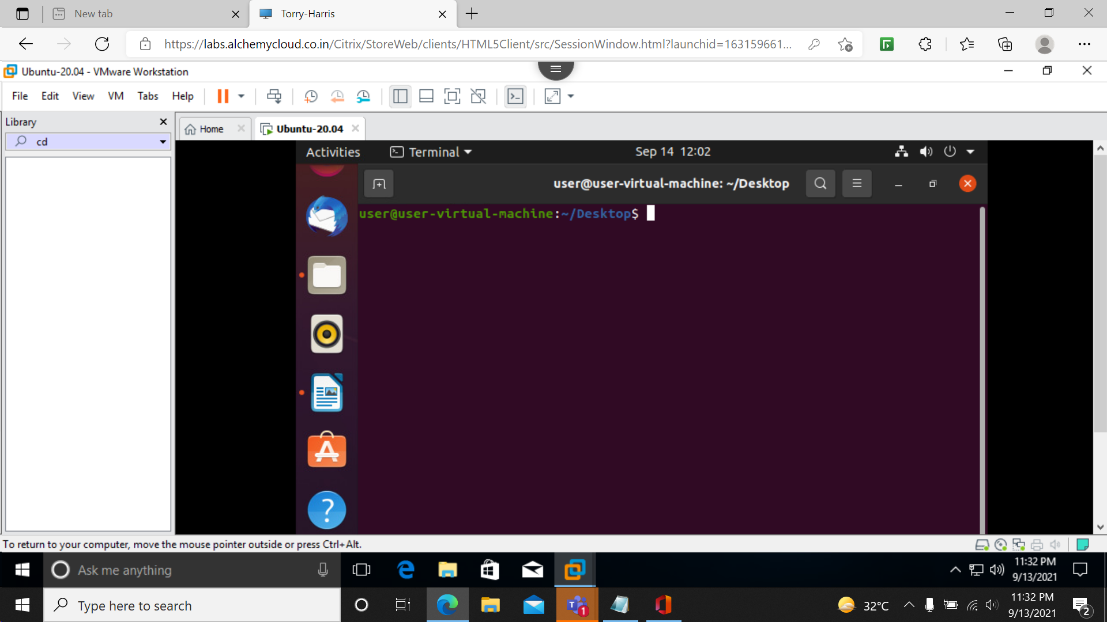

**Man comand_name:**  manual

Used to display the manual of the commands.

**man ls.**

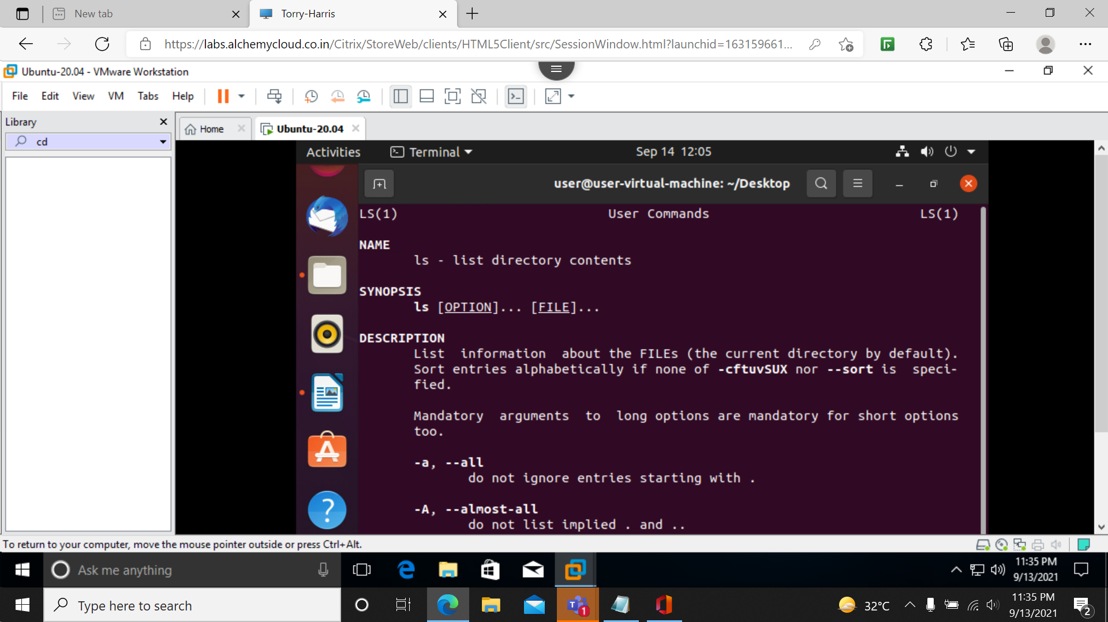

**Touch :**

**To create new file.**

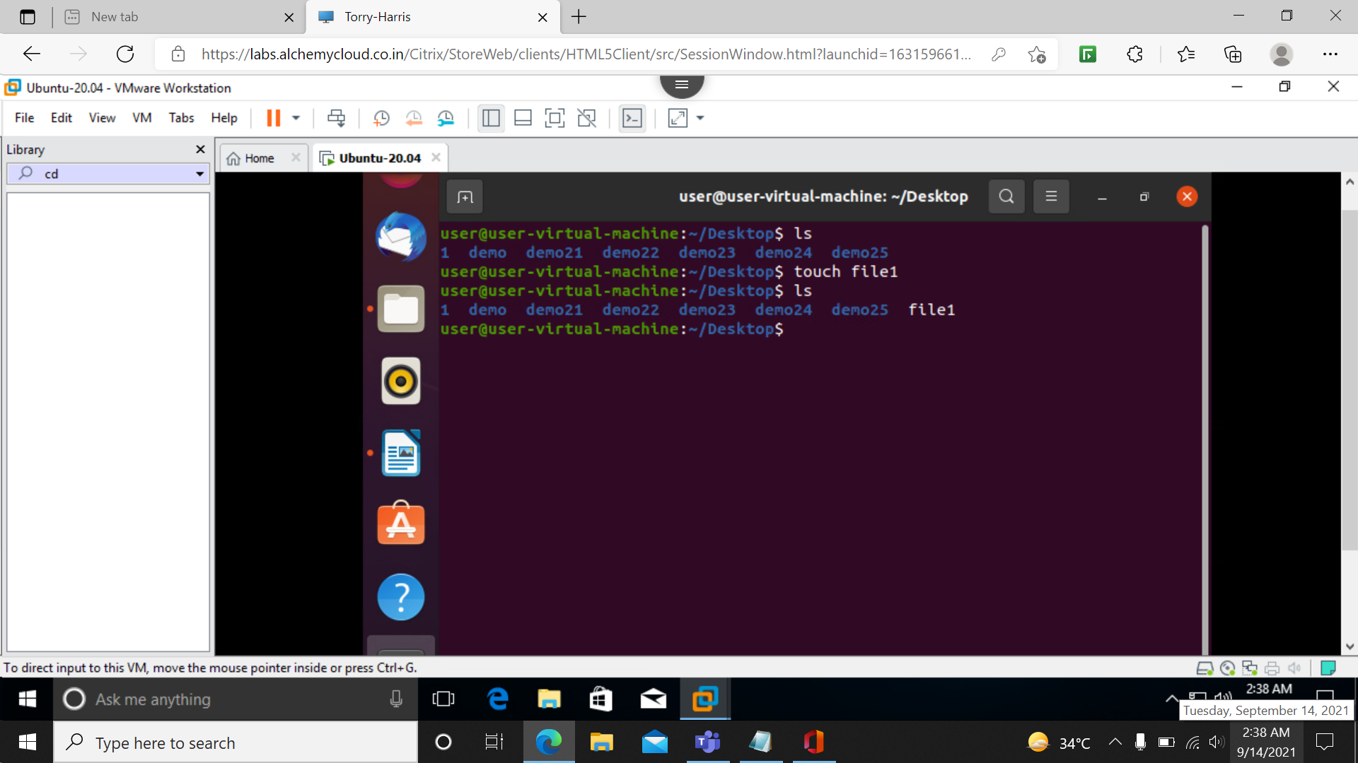

**Rm:** remove file

**Rm file name**

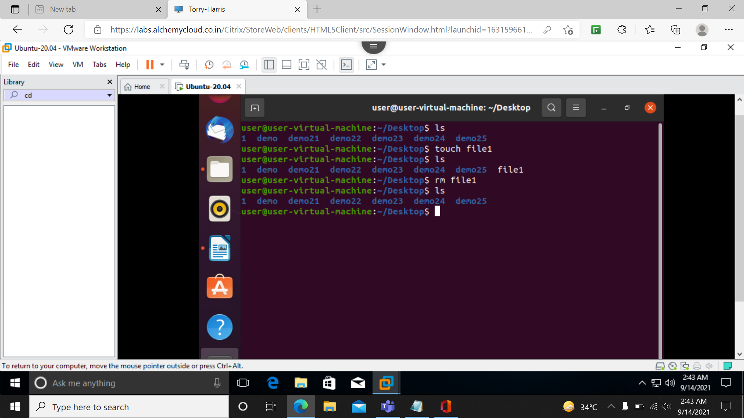

**Who :** who is the user

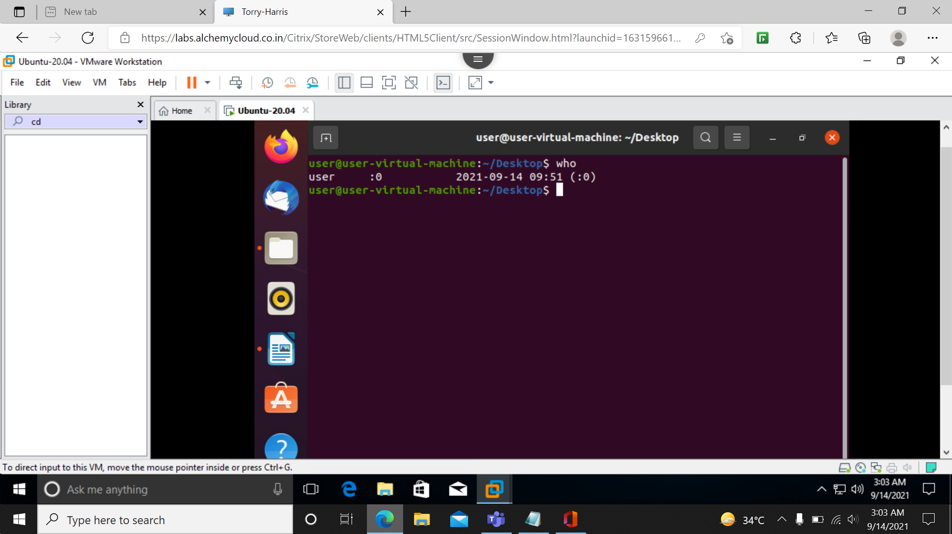

**Date :** to display current date and time

**Cal (calendar):** to display calendar

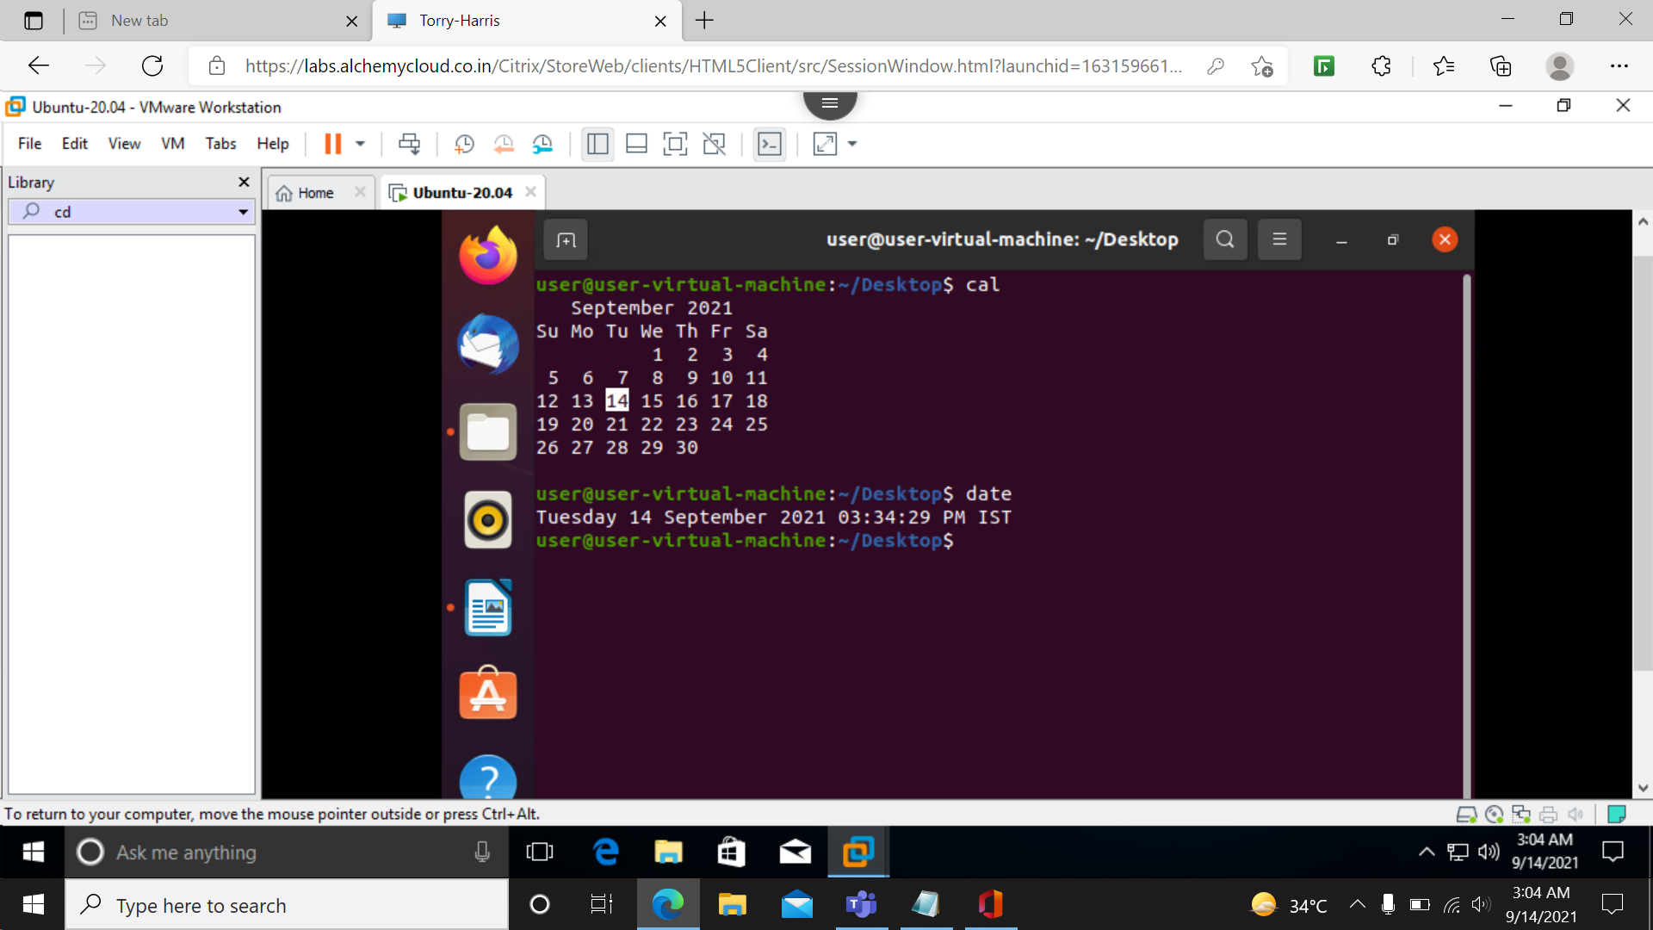

**cat:** to display the content of the file

**tac :** to display the content in reverse order

**sort :**to sort them into alphabetical order

**Cat filename**

**Tac filename**

**Sort filename**

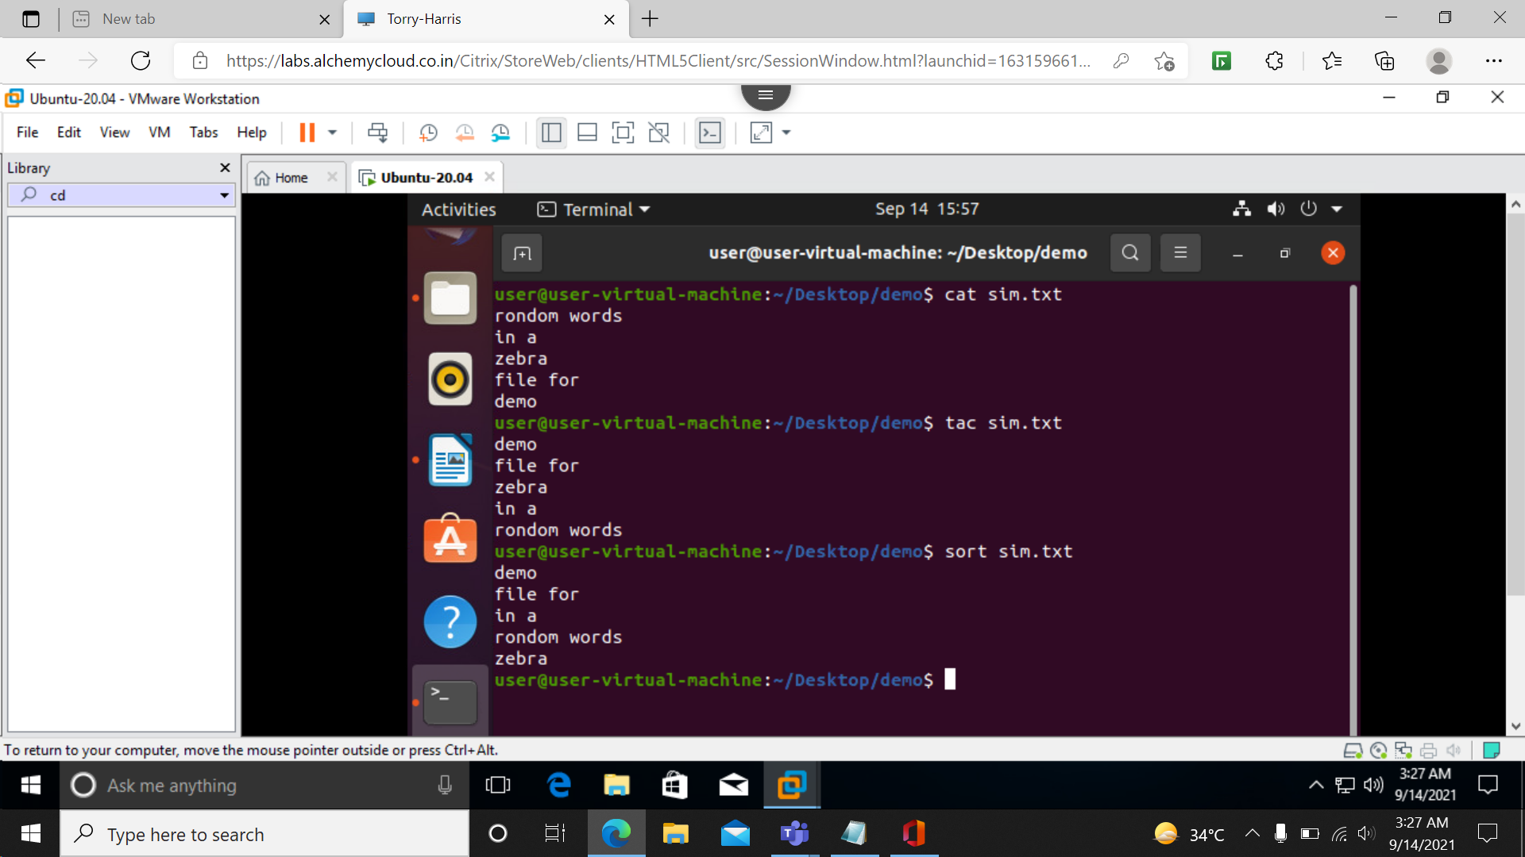

**Sudo apt install package name :** To install packages

**sudo apt install tree #version 1.8.0-1:** to install tree command.

Apt: advanced package tolls

**Sudo apt-get update:**

**Sudo apt-get upgrade:**

**Sudo apt-get update&&upgrade:**

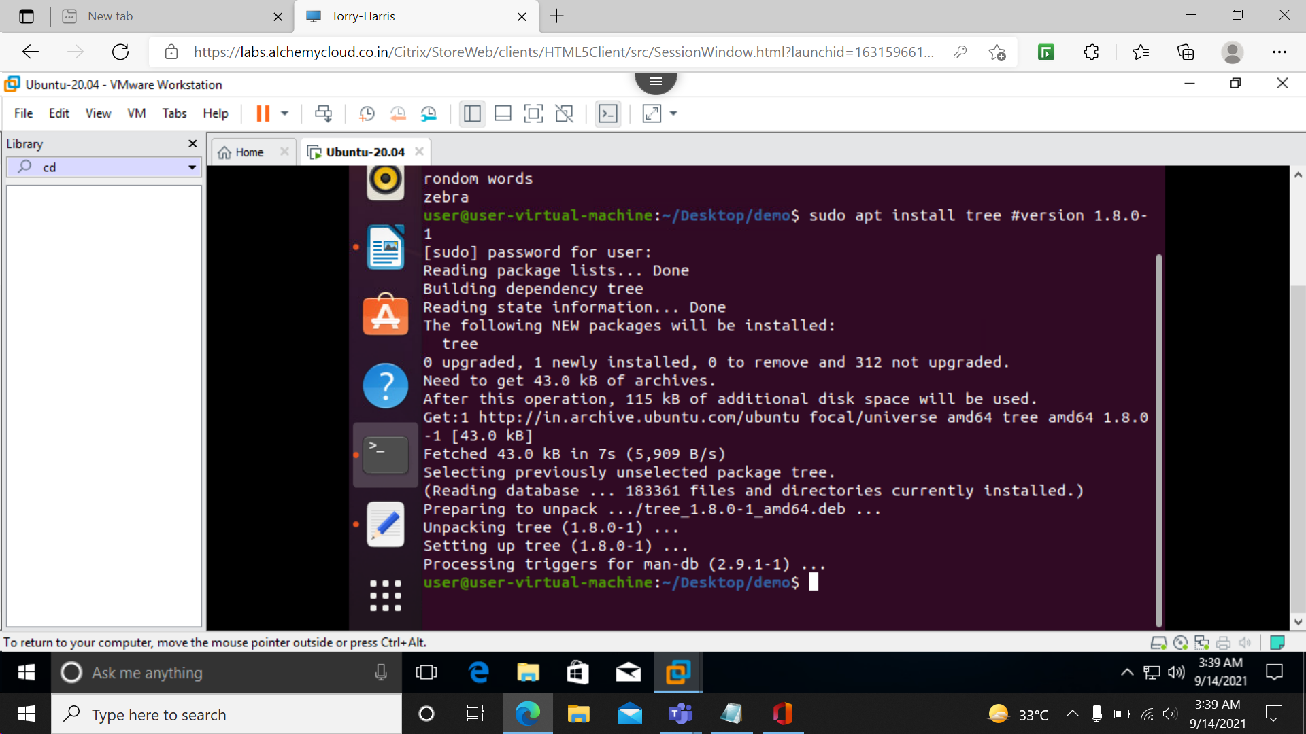

**Tree : to see tree structure of directories system.**

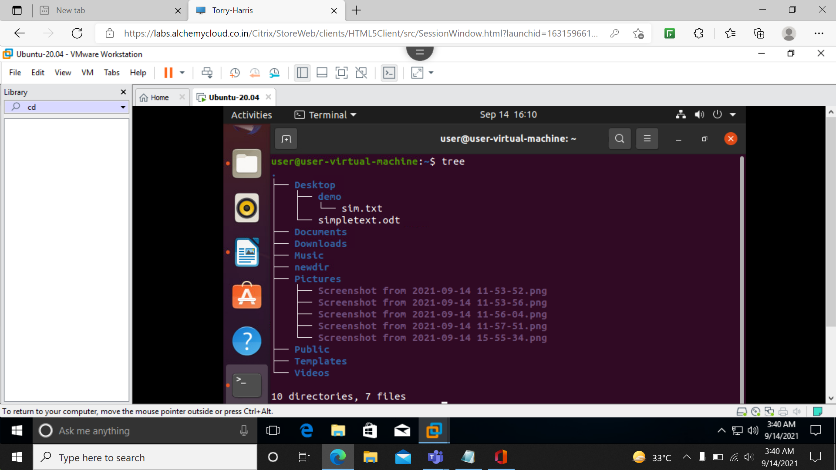

**tree -d:** without internal file structure

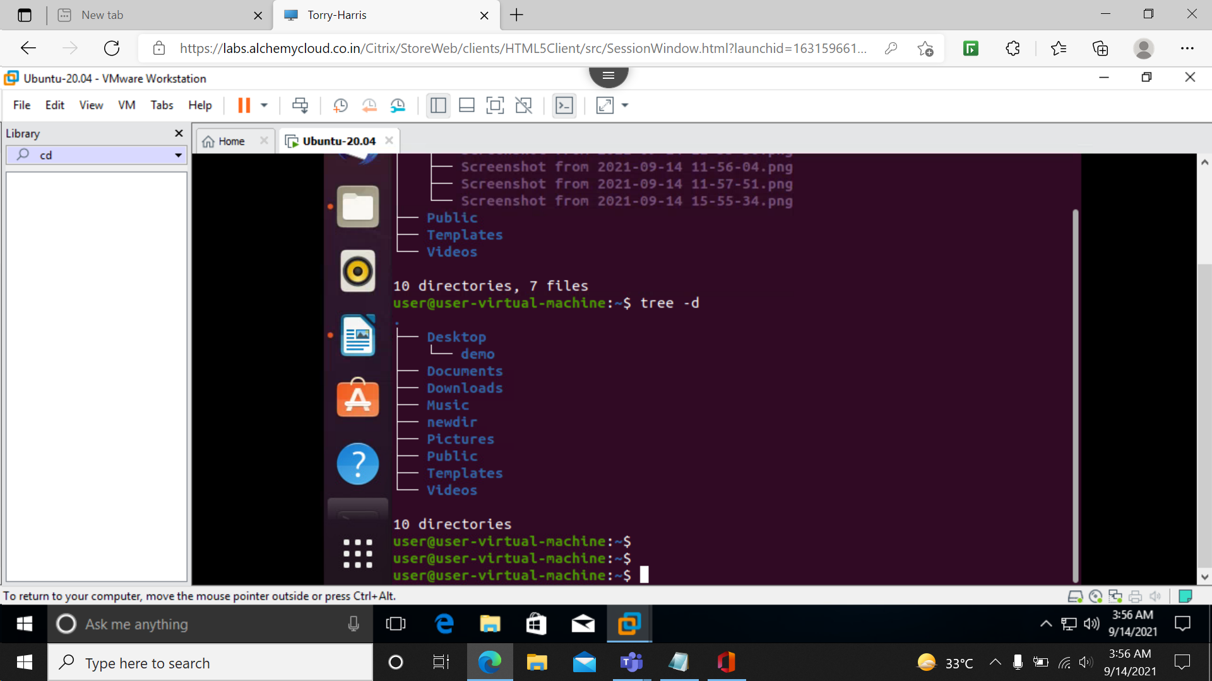

**Passwd:** to change password

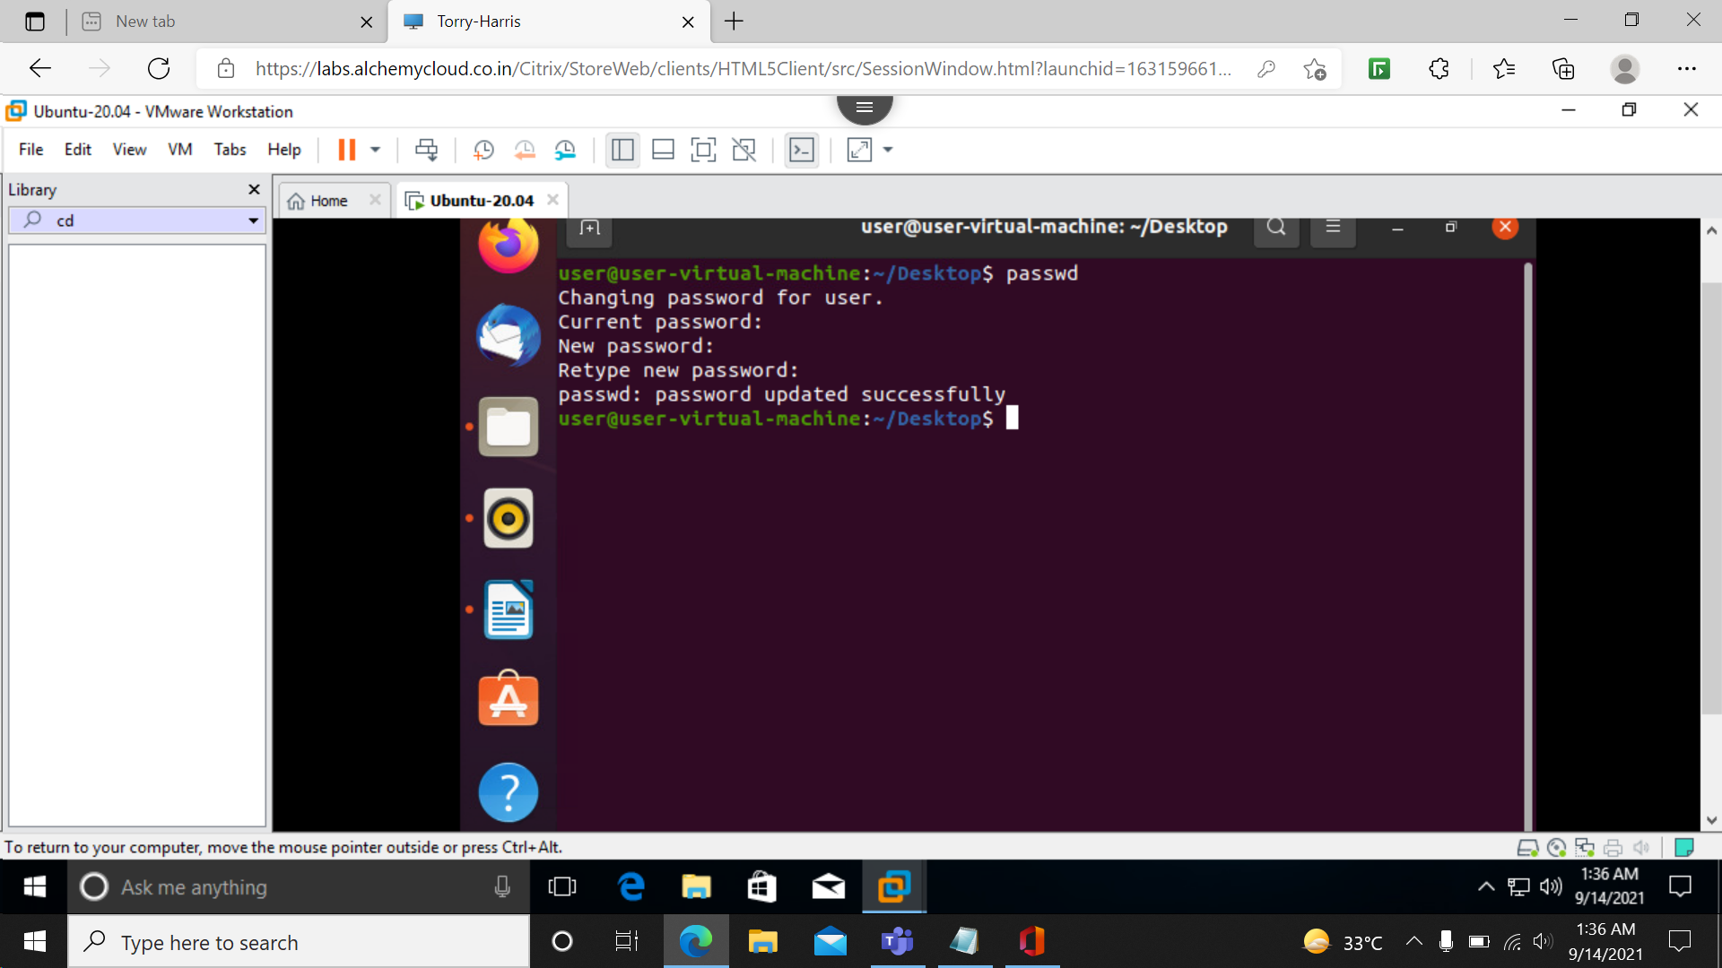

**--help:to get**

**Command name --help:**

**Ls --help**

